Contact List

For all communications to the Association, please contact:
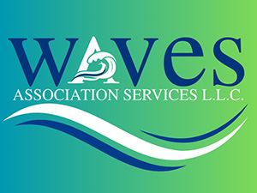
ASSOCIATION AGENT
Bet Fonua
bet@wavesassocmgmt.com
251-943-7410
ASSOCIATION BOOKKEEPER
Brandi Deemer
brandi@wavesassocmgmt.com
251-943-7410
Waves Association Services, LLC
7801 Highway 59, Suite B, Foley, AL. 36535
Association Mailing Address
PO BOX 587, GULF SHORES, AL. 36547

