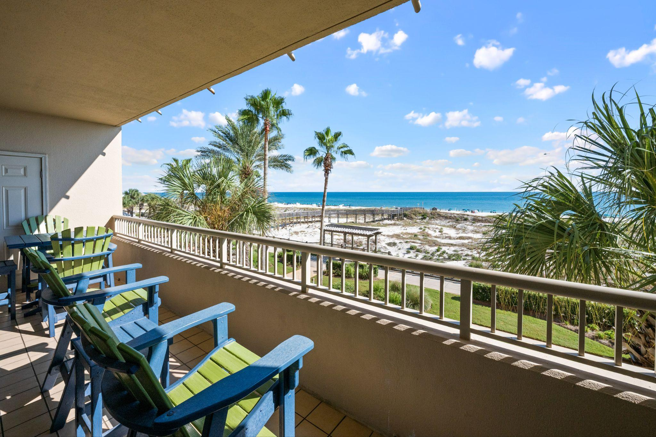
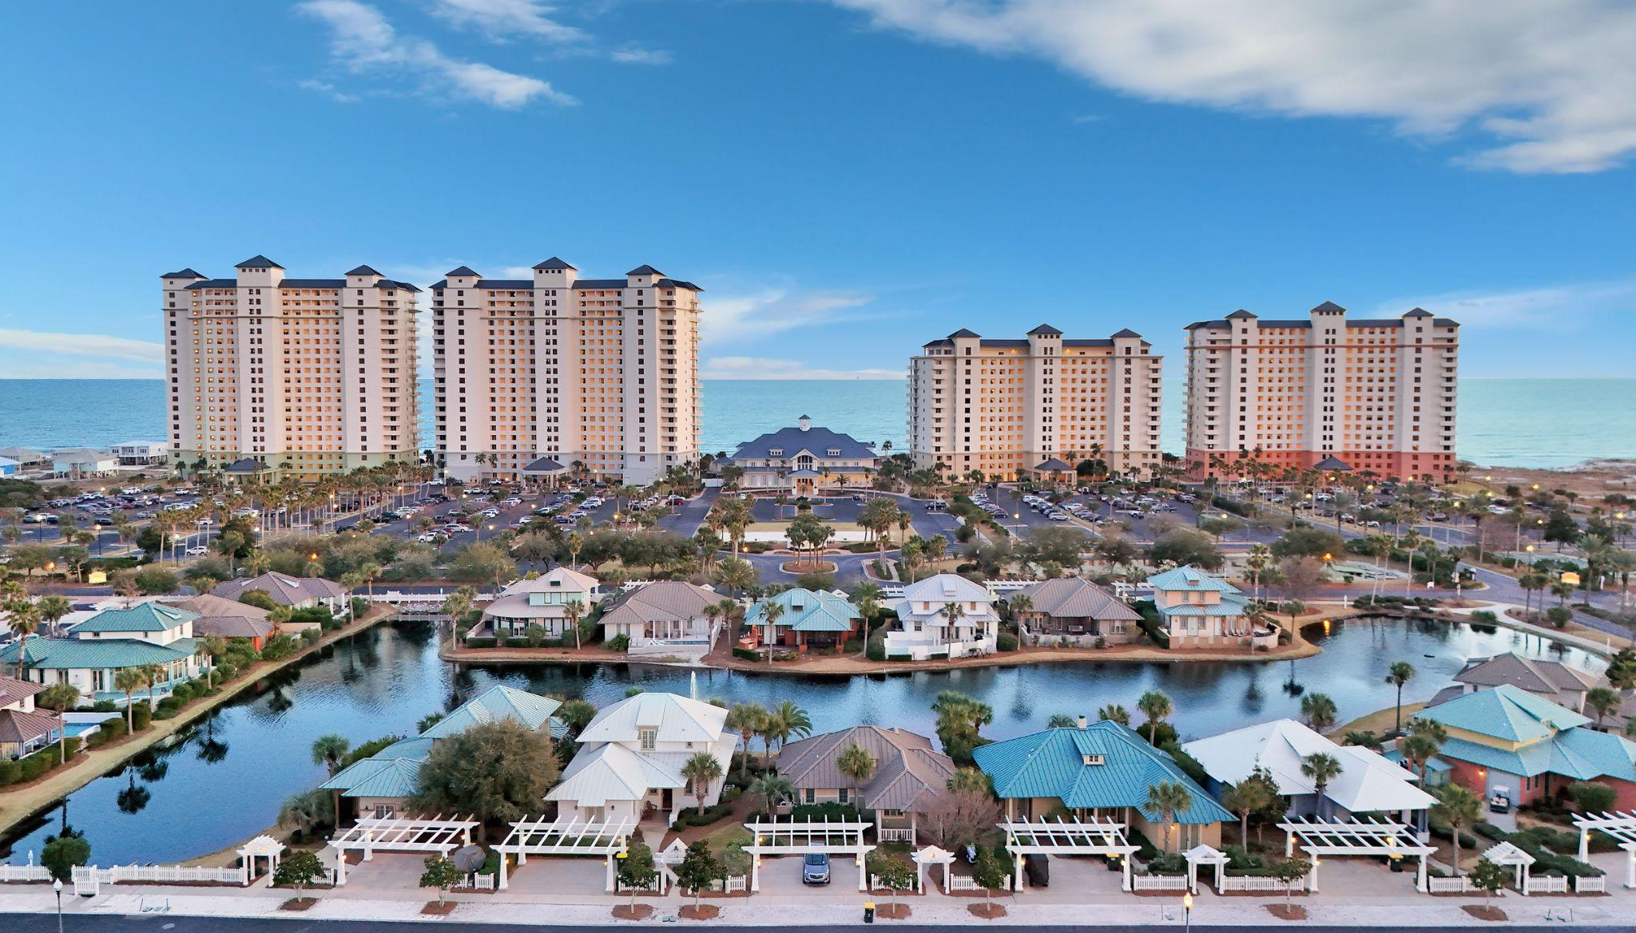
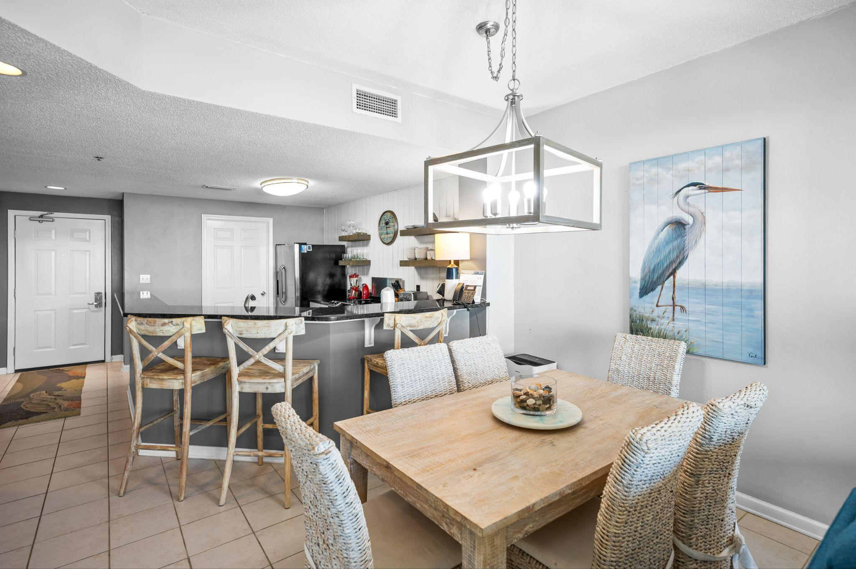

Catalina C307

Common Info:
Additional Fact/Cost of Ownership:

HOA: $685/monthly
Taxes: $3,100
Beach Mouse: $50
Annual Kaba lock fee: $70
Master Acct Dues: $80
Wifi, cable & phone: $80
Rented through Spectrum Resorts.
2023: $39,364
2024: $30,715
2025 as of 11/28: $27,647

- 2 beds/2 baths
- 1,041 SQFT
- Built in 1998
- $543 per SQFT
- Fully Furnished
- Stainless Steel Appliances
Amenities:
- Multiple indoor/outdoor pools
- Fitness center
- Full-service Spa
- Tennis & Racquet Club
- On-site Dining
- Beach Services
Unique Features:
- Microwave drawer built into stove
- Bonus Keurig
- Counter wine cooler
- Master bed invites you to relax with separate bathroom & access to the gulf facing balcony

